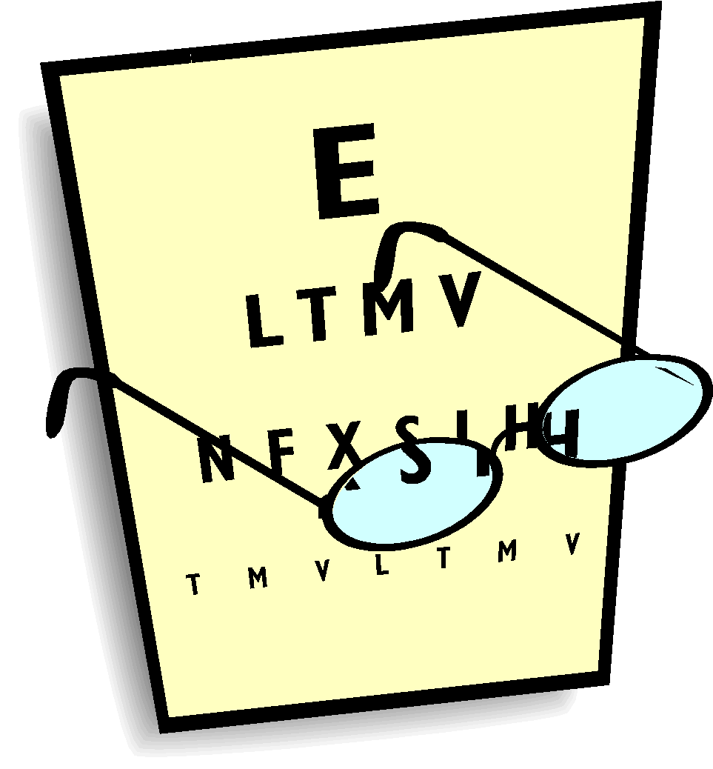
PHYSIOLOGY HONORS COURSE POLICY
Science Dept, TOHS
INSTRUCTOR: Dr. Malhotra; E8
OFFICE PHONE: 495-7491 ext 1408 EMAIL: nmalhotra@conejousd.org
Course Assignment website: http://drmalhotrassciencecorner.weebly.com/
Schoology.com (access code: 5XD3C-C2V3G)
Check your grade: https://q.conejousd.org/
PowerPoint lectures/lab manual: Schoology or Google Drive

COURSE TEXTBOOKS AND MATERIALS:
- Anatomy and Physiology: Seeley, Stephens, and Tate; 8th edition; McGraw-Hill Glencoe (Honors Text)
- 2 College ruled composition notebooks
- Pencils and pens (black or blue); colored pencils; ruler

GENERAL INFORMATION:
1. Physiology Honors is a lab based and fast-paced course taught over 2 semesters. The course involves designing physiology experiments, conducting complex labs, team work, several dissections, critical thinking, data collection and analysis…If you are taking this course, you must have done very well in Bio CP or Bio H!
2. Students should familiarize themselves with the policies concerning the laboratory, academic integrity etc. as these policies will be followed for the lecture and laboratory portion of the course.
3. Ask questions if you are uncertain about materials covered during the lectures and lab sessions.
4. Students should bring their prelab to each lab session or they will not be allowed to do the lab. Students may use any reference or supplemental materials available in the class during labs.
5. Labs will begin promptly at the scheduled starting time. Students arriving late may miss important introductory material and lose participation points. Honors students will be challenged with designing their own experiments!
6. Due to the volume of material covered, students will need to spend some "out-of-class" time in the laboratory. Most students make up labs/quizzes during the lunch time. As a prerequisite for maintaining an open lab policy, students must follow all lab safety policies when working in the lab; clean-up after completing work; and return all materials to their appropriate locations when finished with them. As a rule, the lab should be cleaner and more organized when you leave than when you arrived.
7. Students will be working in their lab groups (3 or 4 students) during all the lab periods. To get credit, each student should actively participate in the group activities. Your group will be evaluated for data collection/analysis, team work, and complete clean up after each lab.
8. All students are required to demonstrate proficiency in both spelling and pronunciation of the terminology presented in this course. Failure to use correct spelling on an exam or quiz will result in a deduction of points!
EVALUATIONS:
1. Practical exams: There will be three (3) practical exams given this year. Each exam will be worth 100 points. Each practical exam consists of 2 parts: part 1 is “practical” in nature where you are expected to identify/classify the structure etc.; part 2 is made up of short answers and multiple choice questions. Please note that spelling counts.
2. Chapter tests: Each chapter will be followed by a multiple choice test. A test study guide will be provided for most tests and all important dates are posted online.
3. Quizzes: A series of reading and lab quizzes will be administered throughout the semester. The format of the quizzes may be multiple-choice, short answer, matching, and/or fill-in. Students may use their hand-written reading notes on the quizzes! Most Quizzes WILL BE ANNOUNCED IN ADVANCE.
4. Peer Group presentations: Each peer group is required to choose a topic from this course and prepare a presentation during the semester. Follow all guidelines given in the PGP handout.
5. Participation: 40 points will be awarded/semester as a participation grade. Factors such as attendance, technique, appropriate lab behavior, failure to prepare for lab sessions and laboratory clean-up will be used to determine the number of points earned by each student for this component of the lab grade.
6. Exam/Quiz Make-up policy: Attendance at all exams/quizzes is mandatory. Missing an exam/quiz will result in a zero unless you provide a valid reason: 1) as documented by a medical professional or campus administrator or 2) as determined by the lab instructor PRIOR to the absence. Students are responsible for all materials missed due to absence. The format of the make-up quizzes may differ from the original test. Depending on the circumstances, students will have up to one week to make up exam/quiz.
7. Point Distribution: The Course points will be distributed as follows:
Practical Exams and chapter tests: 50%
Labs and Lab Reports: 25%
Homework/Class work/Quizzes: 25%
8. Attendance Policy: Because of the volume of the material covered in this course, it is critical that students attend all lectures and lab sessions. Students must give prior notification to the lab instructor to be considered for an excused absence. One unexcused absence will result in the loss of 20 participation points and the second unexcused absence will result in the loss of all participation points. Two late arrivals (10+ minutes) to class will constitute one unexcused absence and result in the loss of participation points. Students should read the attendance policy in their planners for further information concerning absences.
9. Extra Enrichment assignments/Lab Service: Students need my permission to complete any extra enrichment assignments or lab service.
10. If caught cheating and/or assisting, the parents will be called or sent a letter home; test grade will be reduced to a Zero, student will receive a "U" for cooperation, work habits and lose all participation points.

Note: Please have a supportive environment at home so that students can study and complete their homework. If you have any questions, feel free to email me anytime. I look forward to having your child in my class this year!

Print Student name__________________________________________ Period___________________________
Student’s Signature_________________________________ Student Email _______________________________
Parent/guardian’s signature _____________________________ Parent e-mail_____________________________
Date ___________________________

